Name:Yakshitha Sri N D
Registration number:2611003020166 ROOM 1:

Task 1 – What is Networking?

Steps Followed:
- I opened the “What is Networking?” room on TryHackMe.
- I went through the introduction and learned the basic concept of a network.
- I studied how multiple devices can be connected and communicate with each other.
- I went through the example involving Alice, Bob and Jim to understand how devices can be connected in a network.
- I answered the question based on the concept explained in the task.

Question: What is the key term for devices that are connected together?
Answer: Network

What I learned:
I learned that a network is a group of connected devices that can communicate and share information with each other. I also understood why networking is an important part of cybersecurity.

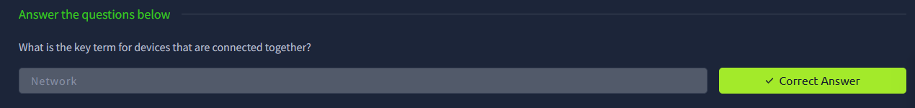

Task 2 – What is the Internet?

Steps Followed:
- I moved to the “What is the Internet?” section of the room.
- I learned that the Internet is a large network made up of many smaller networks.
- I studied the example involving Alice, Zayn, Toby, Bob and Jim to understand how different networks communicate.
- I learned the basic difference between private networks and public networks.
- I reviewed the information about the creation of the World Wide Web.
- I answered the question given at the end of the task.

Question: Who invented the World Wide Web?
Answer: Tim Berners-Lee

What I learned:
I understood how different networks are connected to form the Internet. I also learned about public and private networks and the contribution of Tim Berners-Lee in creating the World Wide Web.
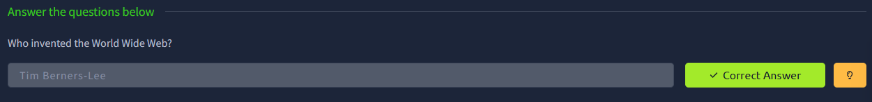

Task 3 – Identifying Devices on a Network

Steps Followed:
- I opened the “Identifying Devices on a Network” section.
- I learned about the two main methods used to identify devices: IP addresses and MAC addresses.
- I studied the structure of an IPv4 address and learned about its four sections, known as octets.
- I learned the difference between public and private IP addresses.
- I went through the basic concept of IPv6 and why it was introduced.
- I studied MAC addresses and their role in identifying network interfaces.
- I opened the interactive lab using the View Site option.
- I followed the scenario involving Bob and Alice.
- I completed the given MAC-address spoofing exercise in the lab.
- After completing the activity, I checked and recorded the flag provided by the room.

Questions and Answers:

Question: What does “IP” stand for?
Answer: Internet Protocol

Question: What is each section of an IP address called?
Answer: Octet

Question: How many sections does an IPv4 address have?

Answer: 4

Question: What does “MAC” stand for?
Answer: Media Access Control

Question: What flag is obtained after the MAC-address spoofing exercise?
Answer: THM{YOU_GOT_ON_TRYHACKME}

What I learned:
I learned how IP and MAC addresses are used to identify devices on a network. I also gained a basic understanding of IPv4, IPv6, public and private addresses, and MAC-address spoofing.
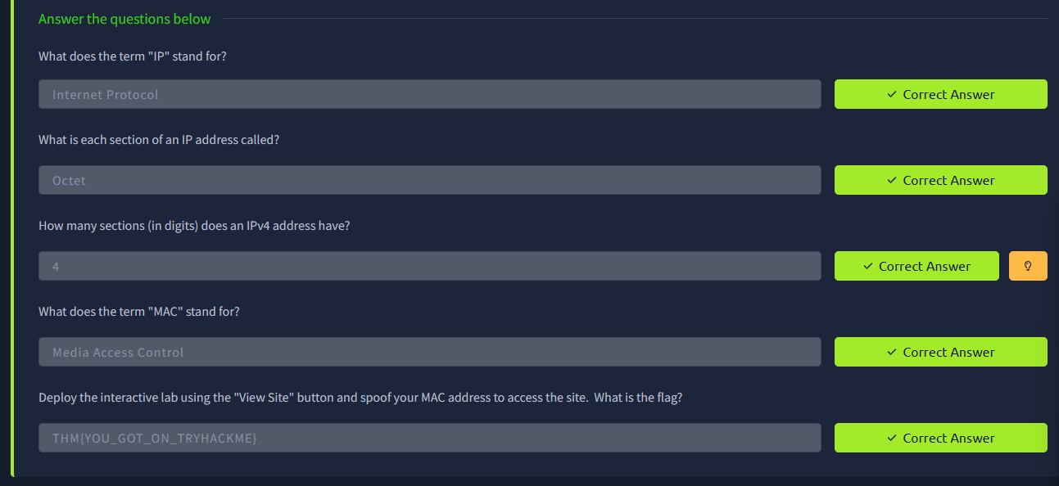

Task 4 – Ping (ICMP)

Steps Followed:
- I opened the “Ping (ICMP)” task.
- I learned the basic purpose of the ping command.
- I understood that ping is commonly used to check whether a destination is reachable.
- I learned that ping uses the ICMP protocol.
- I studied the basic syntax used with the ping command.
- I used the interactive environment provided in the task.
- I entered the required ping command and checked the response.
- I completed the activity and recorded the flag displayed by the room.

Question: What protocol does ping use?
Answer: ICMP

Question: What is the syntax to ping 10.10.10.10?
Answer: ping 10.10.10.10

Question: What flag is obtained when pinging 8.8.8.8?
Answer: THM{I_PINGED_THE_SERVER}

What I learned:
I learned how the ping command is used for basic network troubleshooting. I also understood that ICMP is responsible for the communication used by ping and that the response can help check network connectivity.
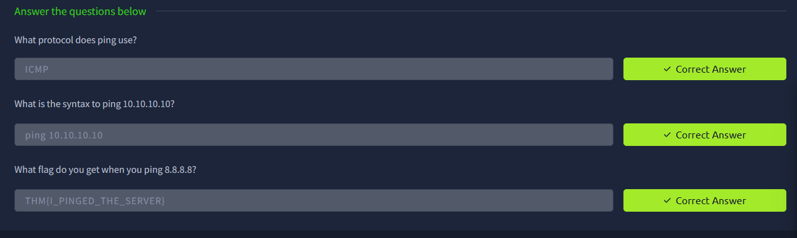

Task 5 – Continue Your Learning

Steps Followed:
- I reached the final task of the “What is Networking?” room.
- I read the instructions provided for continuing the networking learning path.
- I opened the linked “Intro to LAN” room.
- I accessed the next learning module to continue studying networking concepts.
- I completed the task after opening the next room.

What I learned:
I understood that the concepts covered in this room are the foundation for learning more advanced networking topics. The next room provides an opportunity to build on these basic concepts and continue my cybersecurity learning.
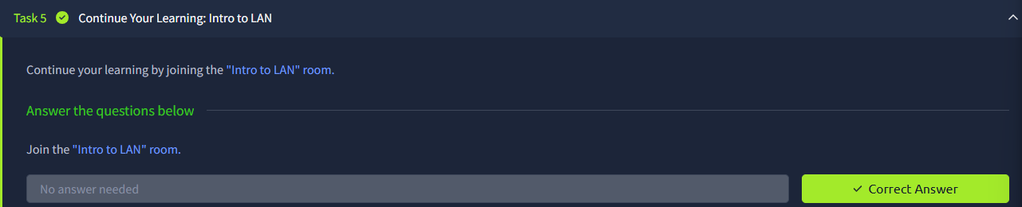

Task 1 – OSI Model

Steps Followed:
- I opened the “Intro to Networking” room on TryHackMe.
- I went through the introduction and read about the OSI model.
- I studied the seven layers of the OSI model and understood the basic purpose of each layer.
- I went through the Application, Presentation and Session layers first.
- I then studied the Transport, Network, Data Link and Physical layers.
- I reviewed how data moves through the different layers during communication.

Question:

How many layers are there in the OSI model?

Answer: 7

Question:

What are the seven OSI layers?

Answer: Application, Presentation, Session, Transport, Network, Data Link and Physical.

What I learned:
I learned how the OSI model divides network communication into seven different layers. I also understood that each layer has a specific responsibilityty and that the layers work together when devices communicate

. 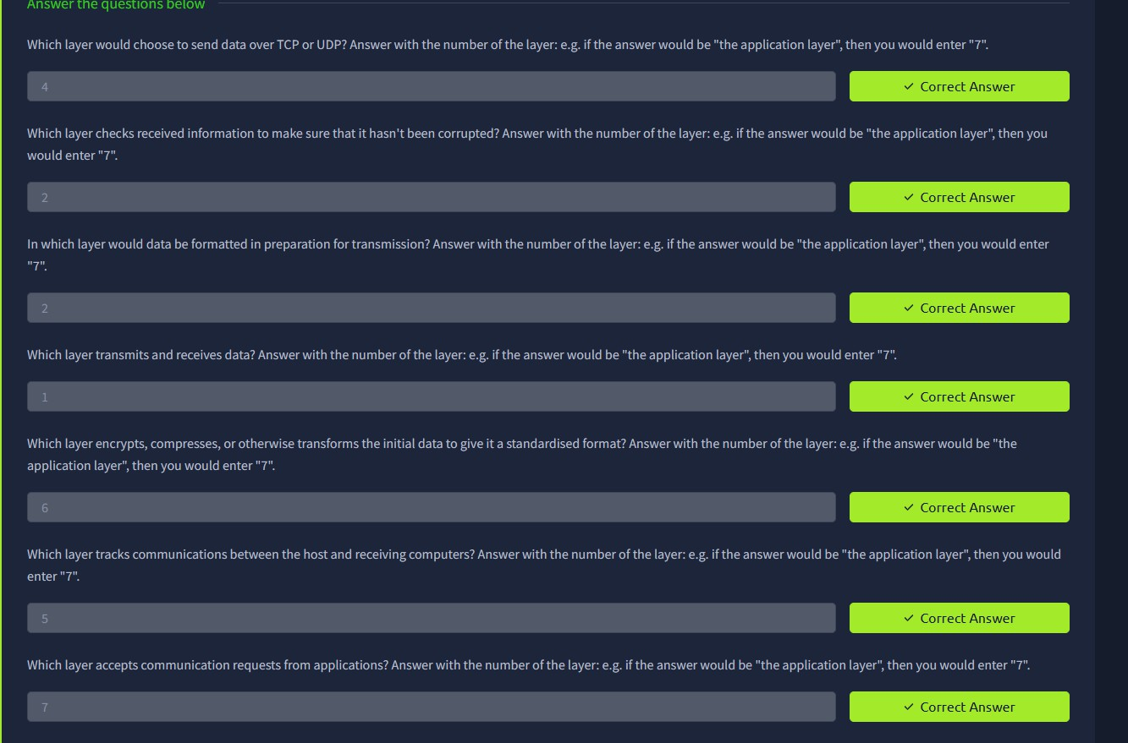

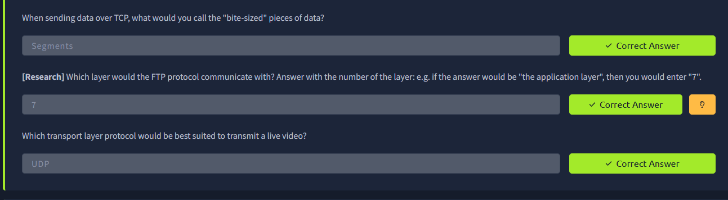

Task 2 – Encapsulation and De-encapsulation

Steps Followed:
- I moved to the section explaining how data is prepared for transmission.
- I studied how information is added to data as it moves down through the networking layers.
- I learned that data can become a segment or datagram, then a packet and finally a frame.
- I then studied what happens when the data reaches the receiving device.
- I understood that the added information is removed as the data moves back up through the layers.

Question:
What is the process of adding information to data as it moves through the layers called? Answer: Encapsulation

Question:
What is the reverse process called? Answer: De-encapsulation

What I learned:
I learned how networking information is added before transmission and removed when the data is received. This helped me understand how data is prepared and processed between two devices.
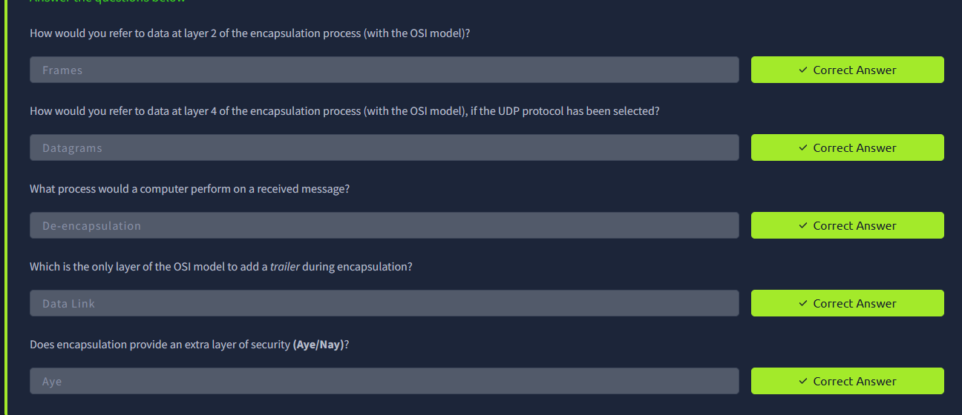

Task 3 – TCP/IP Model

Steps Followed:
- I opened the section about the TCP/IP model.
- I studied the four layers of the TCP/IP model.
- I learned about the Application, Transport, Internet and Network Interface layers.
- I compared these layers with the OSI model.
- I understood that some OSI layers are combined in the TCP/IP model.

Question:
How many layers are in the TCP/IP model? Answer: 4

Question:

What are the four TCP/IP layers?

Answer: Application, Transport, Internet and Network Interface.

What I learned:
I learned that the TCP/IP model is a practical model used for real-world networking. I also understood how it relates to the OSI model.
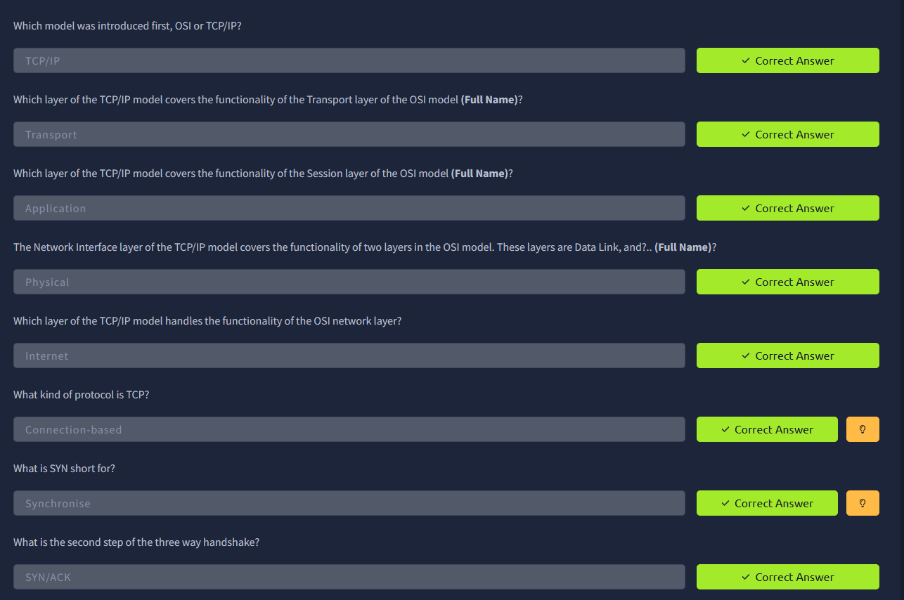

Task 4 – TCP Three-Way Handshake

Steps Followed:
- I moved to the section about TCP connections.
- I studied how TCP establishes a connection between two devices.
- I followed the three messages used during the connection process.
- I learned the order of the messages: SYN, SYN-ACK and ACK.
- I understood that the handshake happens before the TCP connection is established.

Question:
What are the three steps in the TCP handshake? Answer: SYN, SYN-ACK and ACK.

What I learned:
I learned how TCP establishes a connection before communication begins. The three-way handshake helped me understand the basic process used by TCP.

Task 5 – Ping (ICMP)

Steps Followed:
- I opened the Ping (ICMP) section.
- I learned the basic purpose of the ping command.
- I understood that ping is commonly used to check whether a destination is reachable.
- I learned that ping uses the ICMP protocol.
- I studied the basic syntax of the command.
- I used the interactive environment and checked the response from the destination.

Question:
What protocol does ping use? Answer: ICMP

Question:

What is the syntax to ping 10.10.10.10? Answer: ping 10.10.10.10 What I learned:
I learned how ping can be used for basic network troubleshooting. I also understood that ICMP is used by
ping and that the response can help check connectivity and response time.
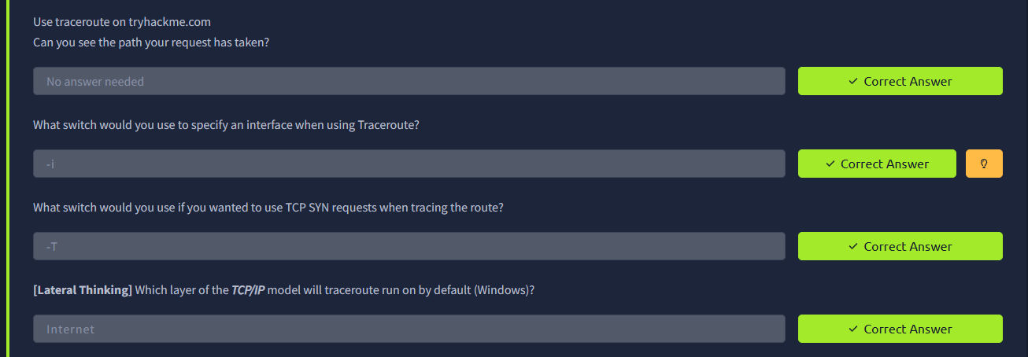

Task 6 – Traceroute

Steps Followed:
- I opened the Traceroute section of the room.
- I read about how traceroute is used to identify the path towards a destination.
- I studied the idea of intermediate hops between my computer and the destination.
- I understood that each hop represents a step taken by the network traffic.
- I reviewed the example output provided by the room.

Question:

What is traceroute used for?

Answer: It is used to identify the path and intermediate hops to a destination.

What I learned:
I learned that traceroute can help me understand the route taken by network traffic. It can also help identify where problems may occur along a network path.

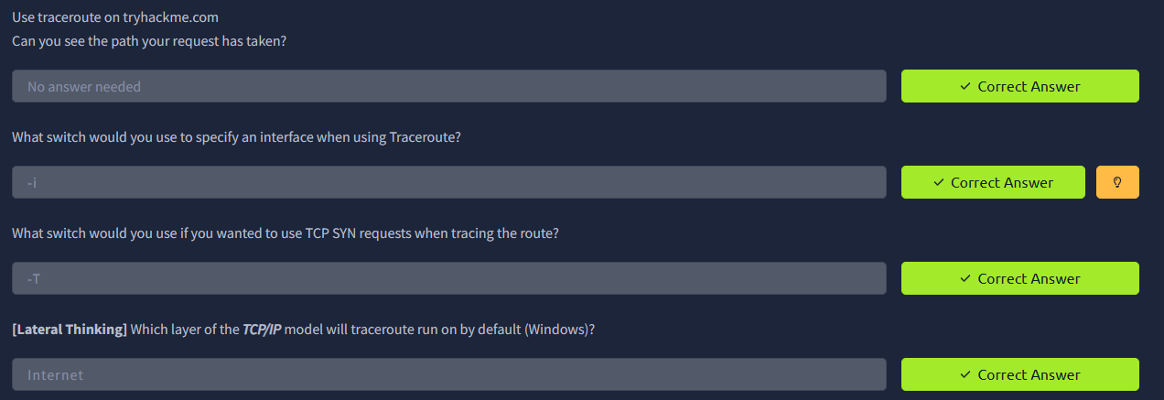

Task 7 – WHOIS

Steps Followed:
- I moved to the WHOIS section.
- I learned that WHOIS can be used to query information about a registered domain.
- I reviewed the example WHOIS output provided in the room.
- I identified information such as registration details and name servers.
- I understood that the amount of information available can depend on privacy and registration settings.

Question:

What is WHOIS used for?

Answer: It is used to query information about a registered domain.

What I learned:
I learned how WHOIS can provide useful information about domains. I also understood that domain information can include registration-related details and name servers.

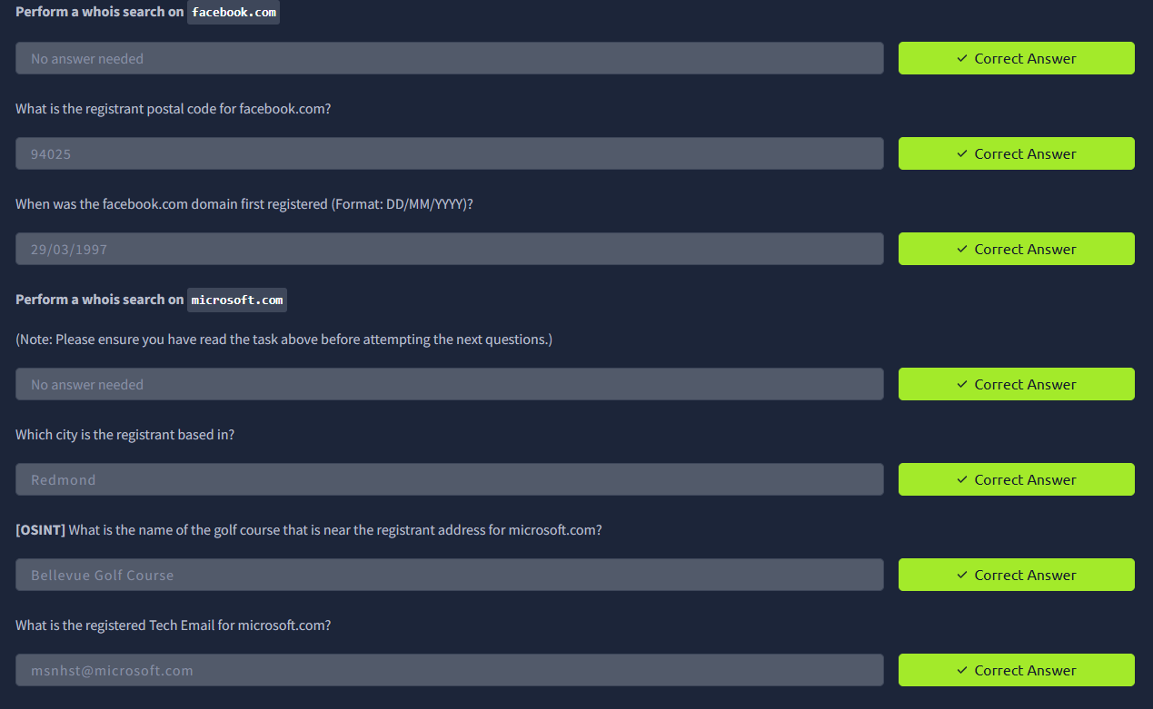

Task 8 – DNS

Steps Followed:
- I opened the DNS section of the room.
- I learned why DNS is needed when people use domain names.
- I studied how a domain name can be translated into an IP address.
- I went through the roles of recursive DNS servers, root servers, TLD servers and authoritative name servers.
- I followed the DNS lookup process from the initial request to the final answer.

Question:
What does DNS stand for? Answer: Domain Name System

Question:

What is the main purpose of DNS?

Answer: To translate domain names into IP addresses.

What I learned:

I learned how DNS makes the Internet easier to use by allowing people to use domain names instead of remembering IP addresses. I also understood the basic hierarchy used during DNS resolution.

Task 9 – dig and TTL

Steps Followed:
- I moved to the section about the dig command.
- I learned that dig can be used to manually query DNS information.
- I reviewed the ANSWER section of a DNS response.
- I studied the TTL value shown in the response.
- I understood that TTL indicates how long a DNS record can remain cached before it should be requested again.

Question:
What command can be used to manually query DNS information? Answer: dig

Question:

What does TTL indicate?

Answer: How long a DNS record can remain cached.

What I learned:
I learned how the dig command can be used to inspect DNS information. I also understood the purpose of TTL and how DNS caching works at a basic level.

